# Databases Advanced Exam

# Most Wanted(MVC)

Racing has become an essential part of some people’s life. It’s the energy that flows through their veins. However, some races get out of control creating massive traffic disasters, which forced the Laws to create The ARPU – Anti-Race Police Unit… A specialized unit, which does not spare even a penny, when it comes to stopping races. Their performance tuned cars are on par with most racers’ cars and they aren’t afraid of crashing them.

## Functionality Overview

The ARPU has hired you as their database developer, to implement a **database application**. The application should be able to easily **import** hard-formatted data from **XML** and **JSON** and **support functionality** for also **exporting** into the imported data. The application is called – **Most Wanted**.

Look at the pictures below to see what must happen:

* Home page before importing anything:

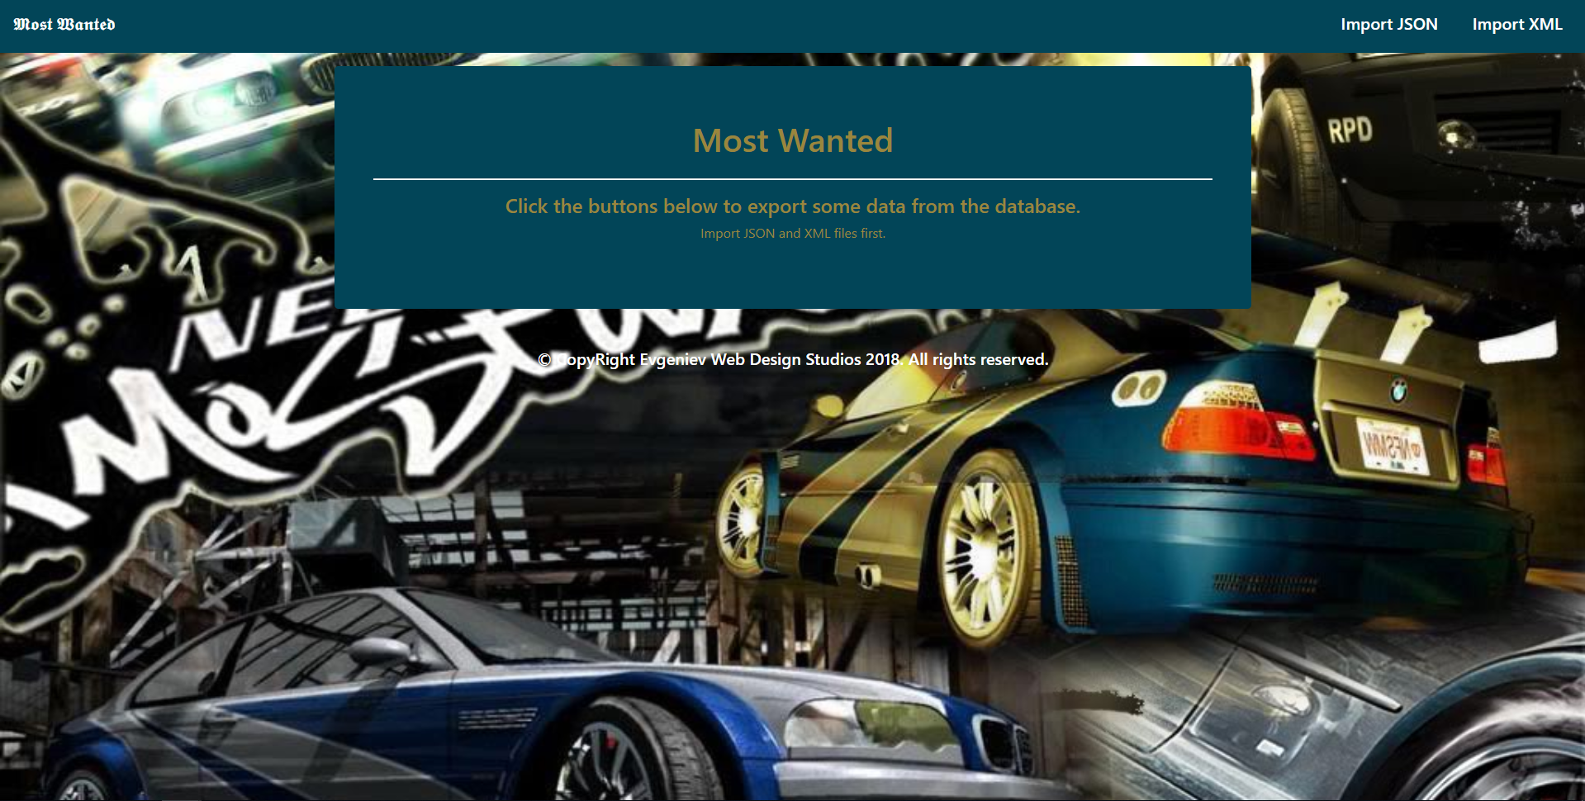

* Import JSON page before importing anything:

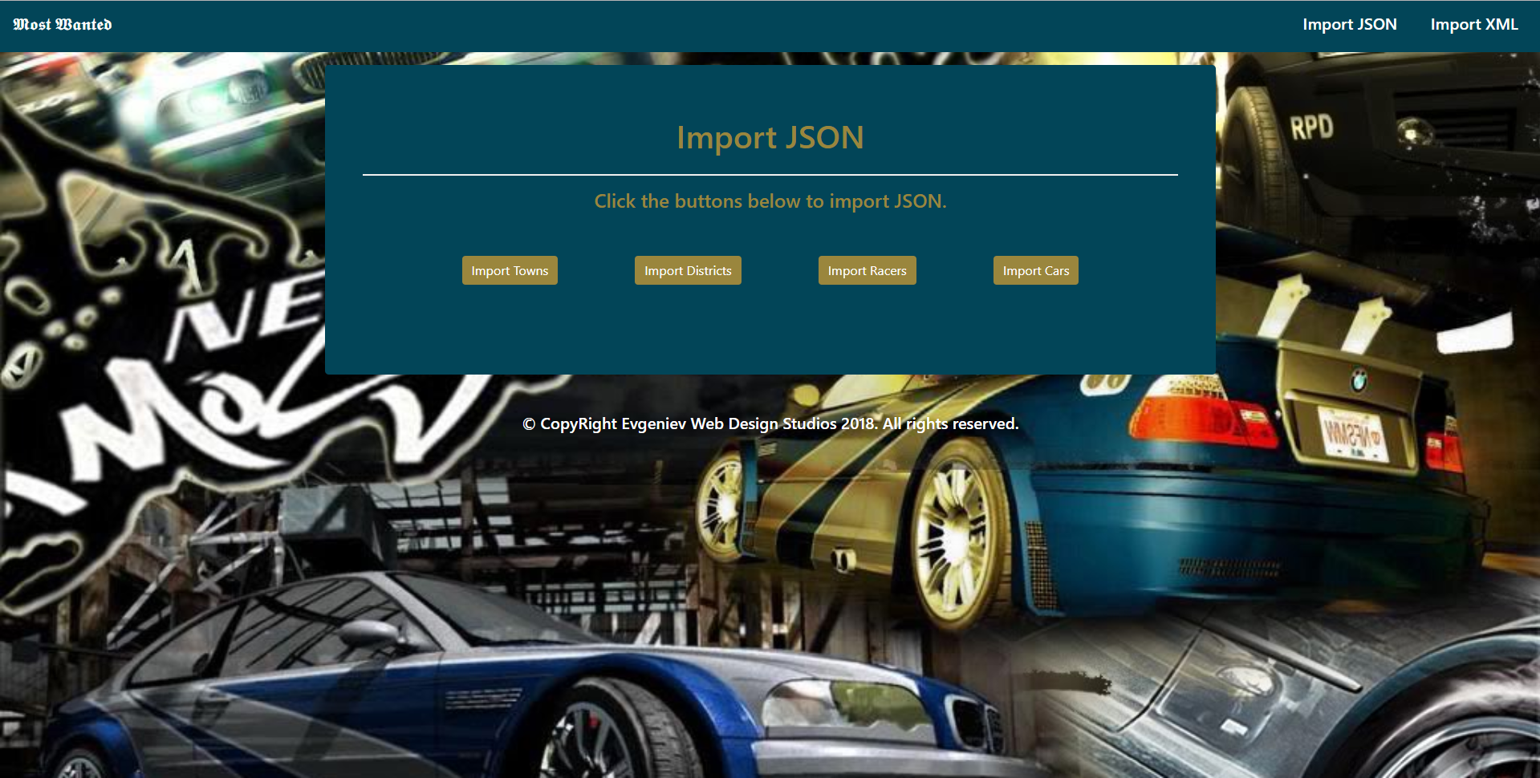

* Import XML page before importing anything:

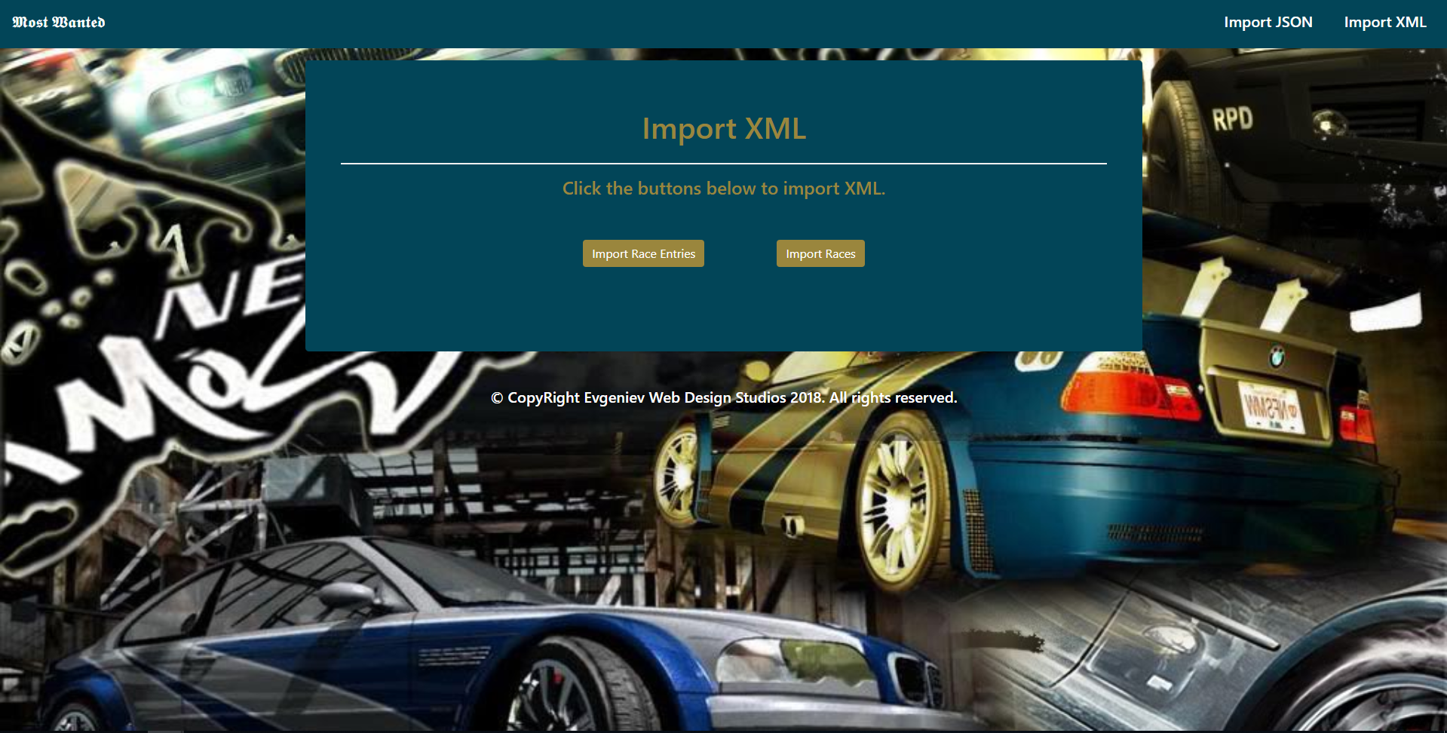

* Import Towns page after reading the **towns.json** file:

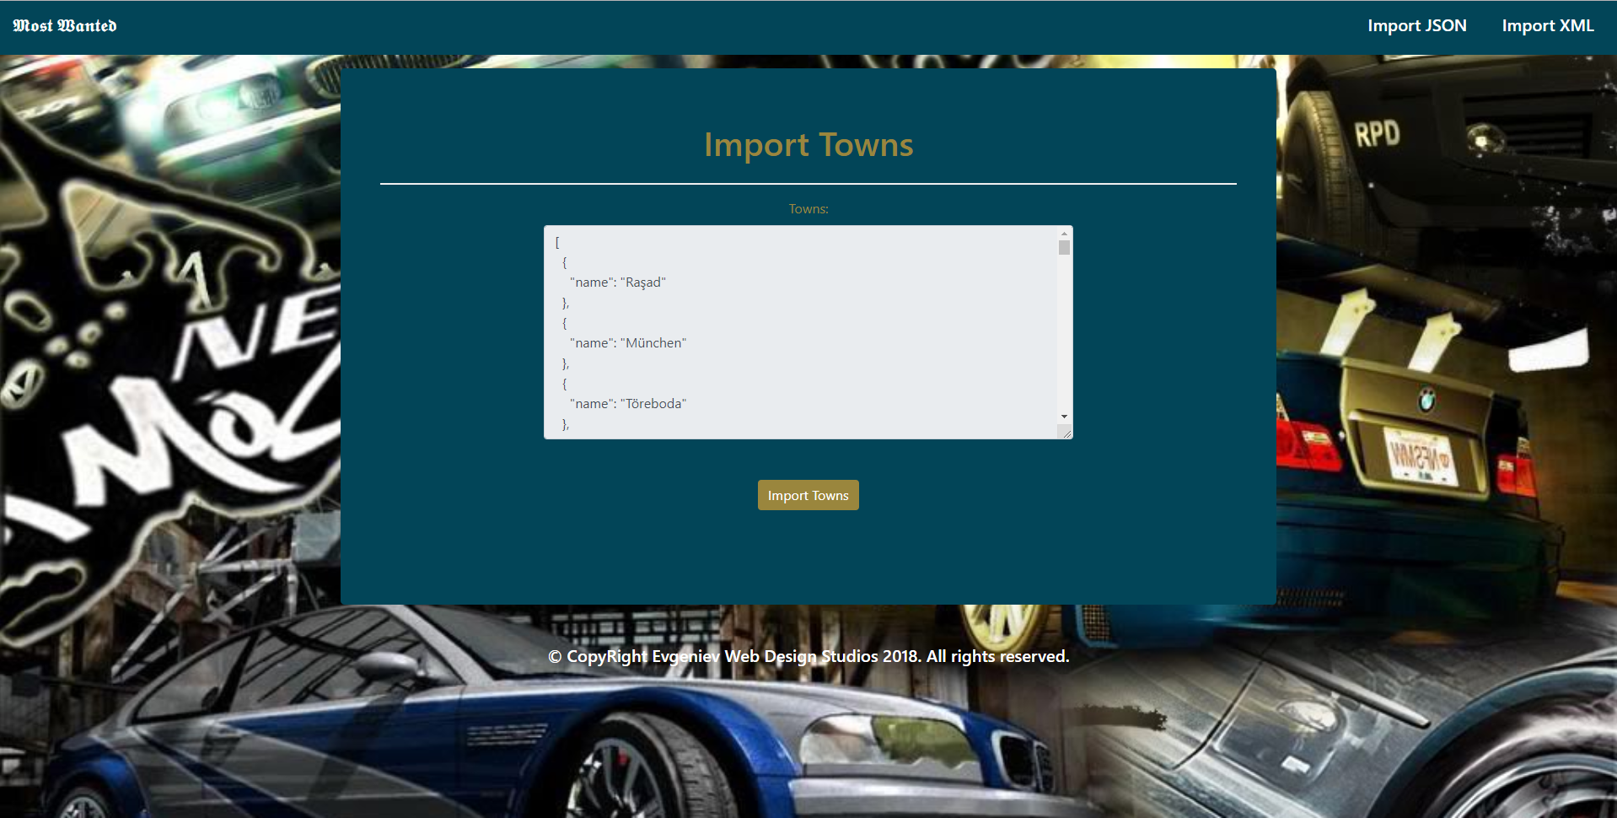

* Import Districts page after reading the **districts.json** file:

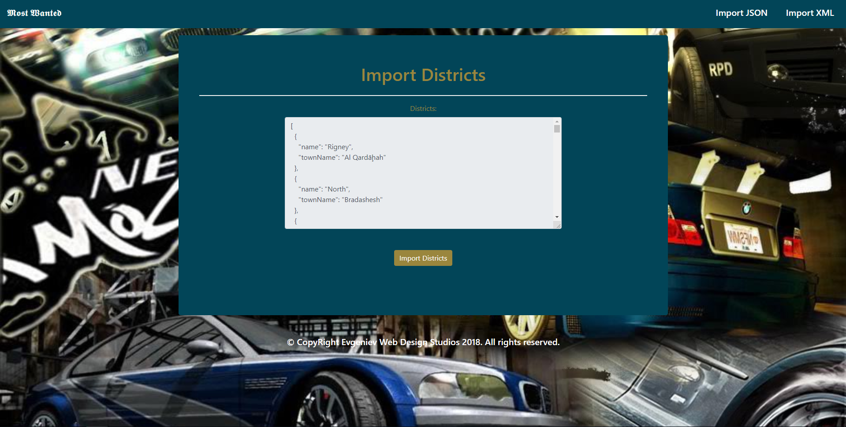

* Import Racers page after reading the **racers.json** file:

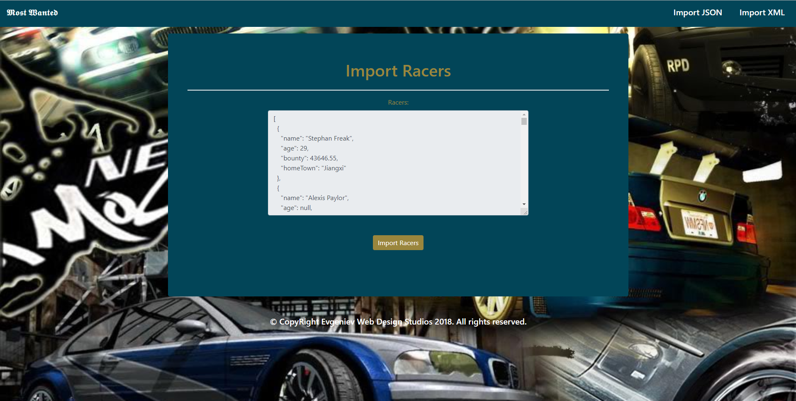

* Import Cars page after reading the **cars.json** file:

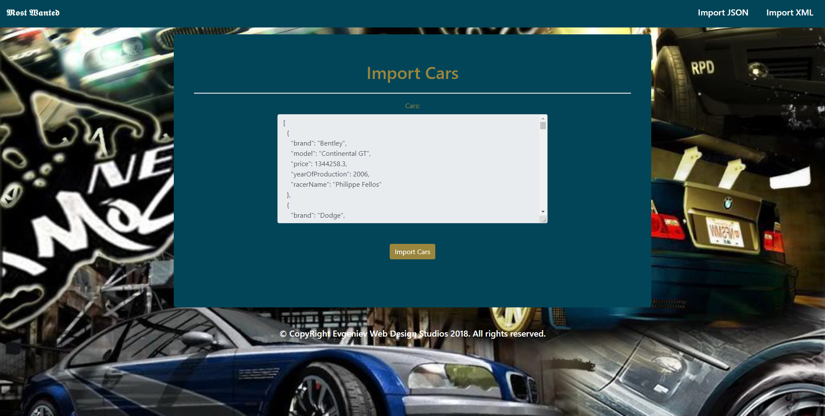

* Import Race Entries page after reading the **race-entries.xml** file:

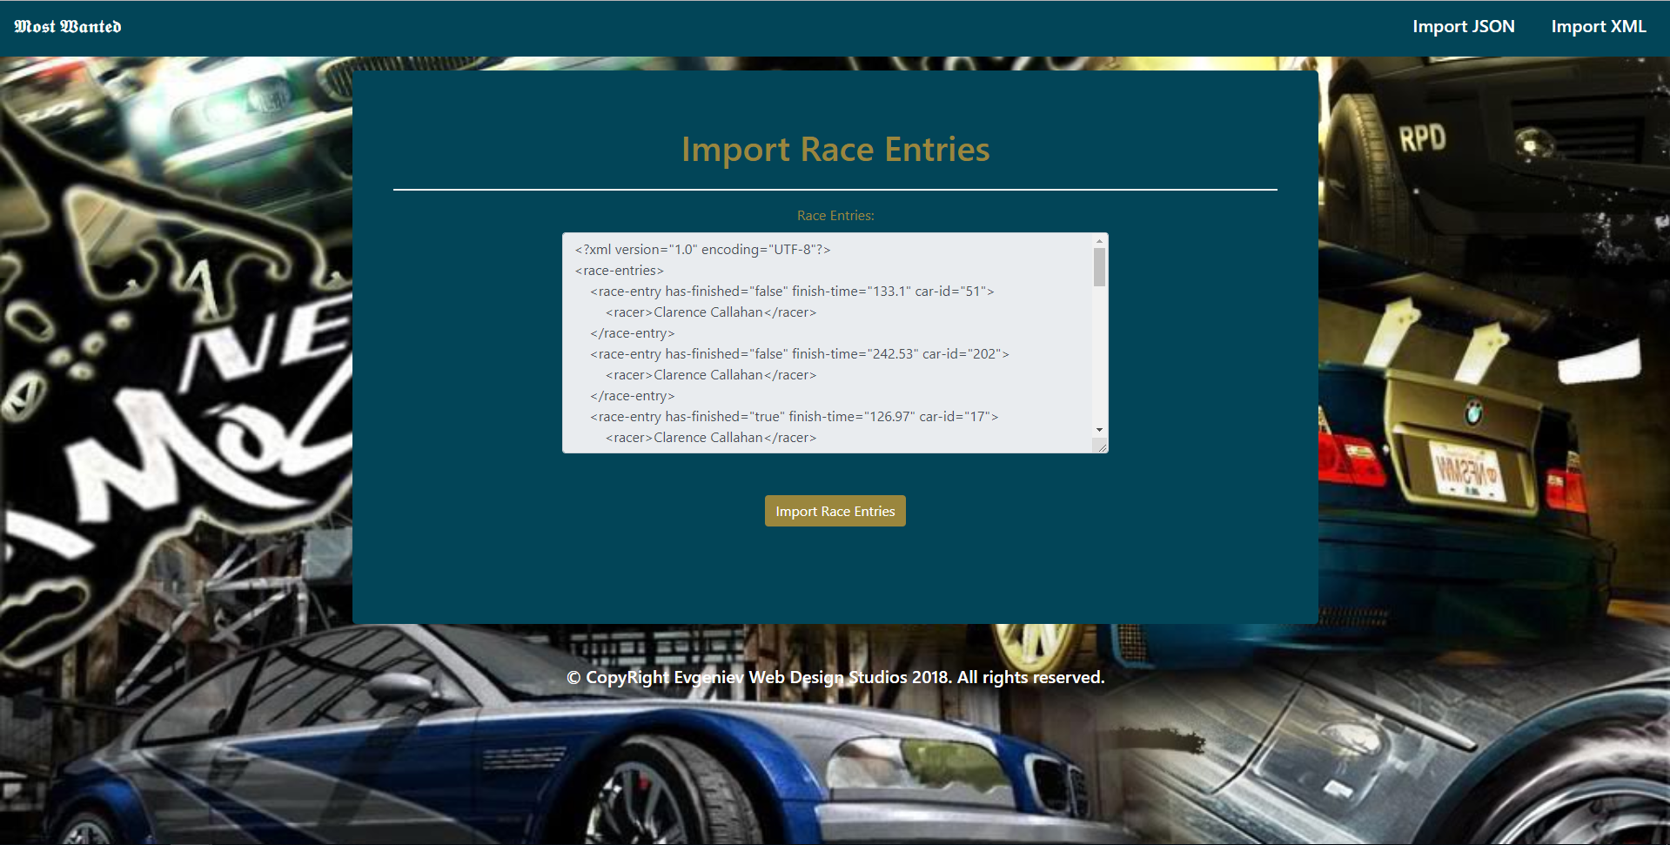

* Import Races page after reading the **races.xml** file:

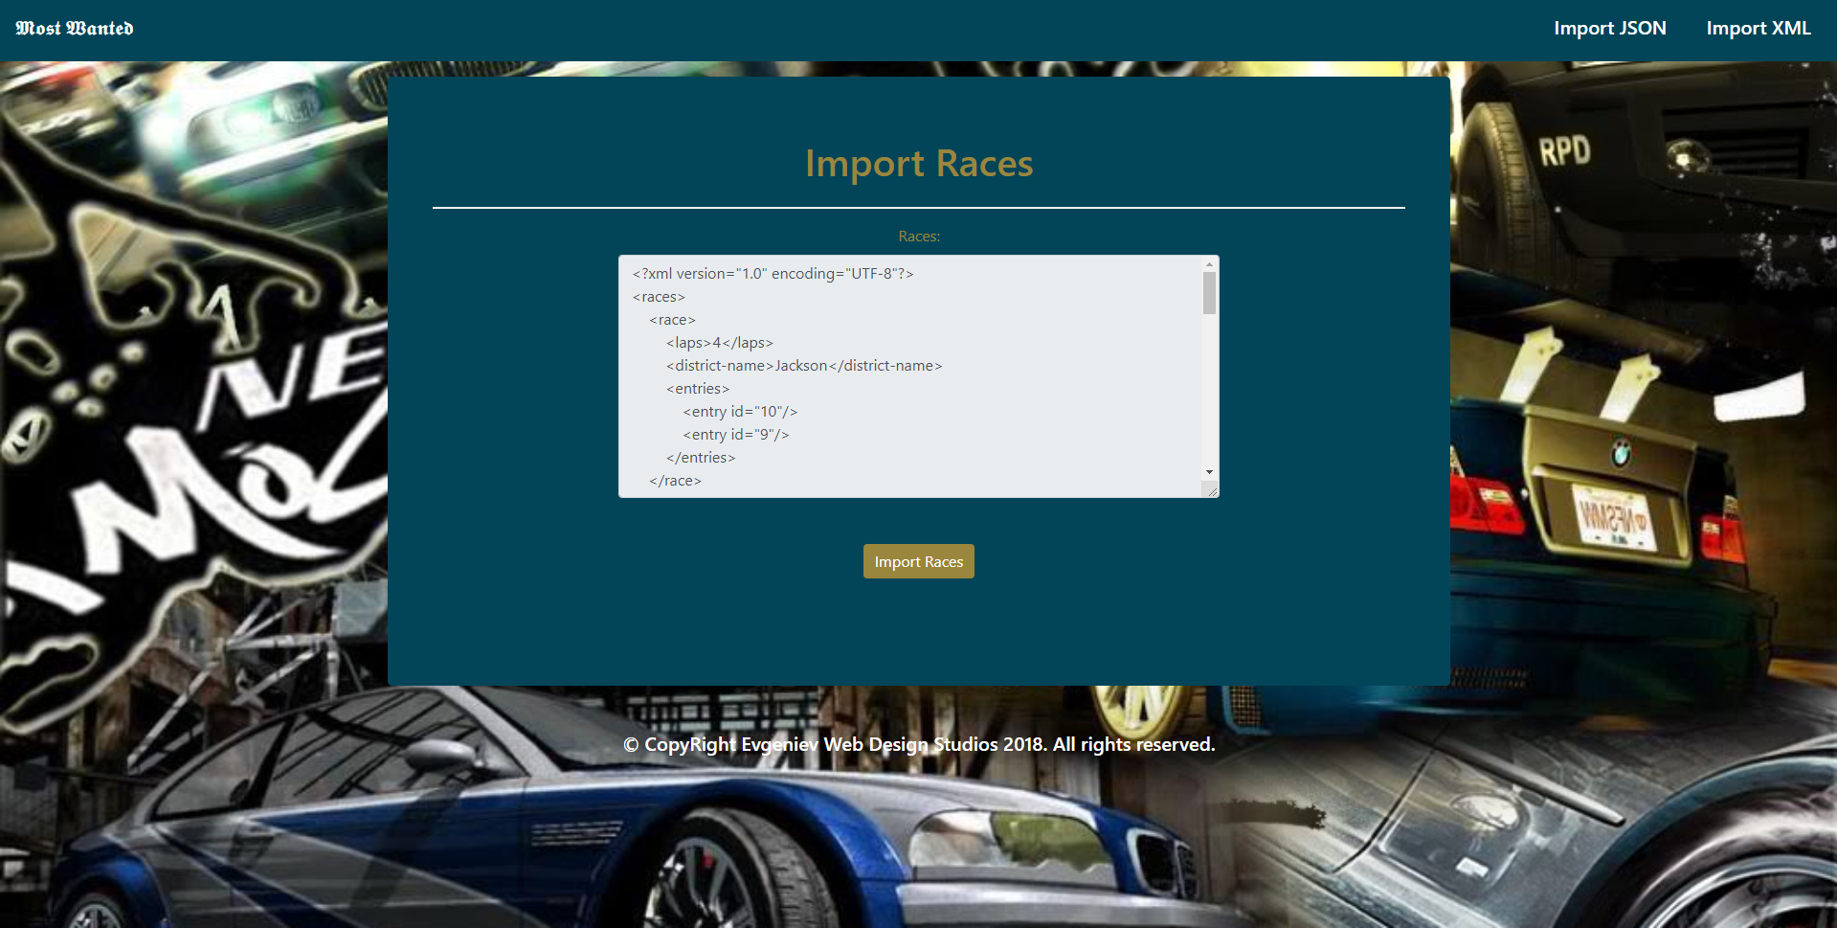

* Import JSON page after importing the given data:

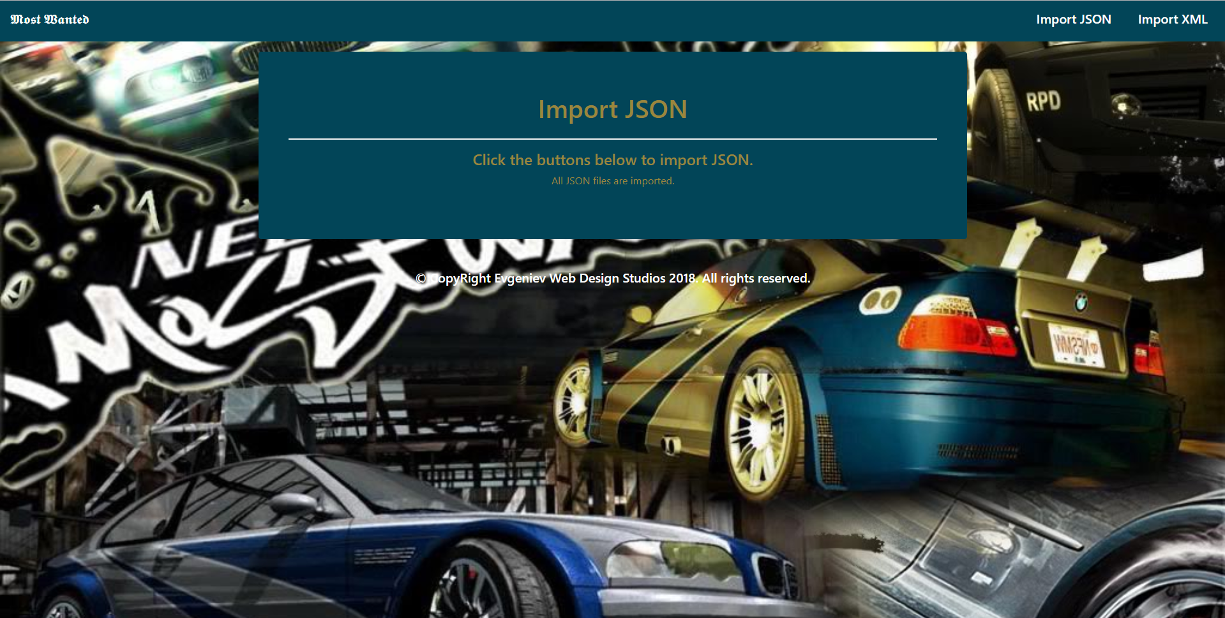

* Import XML page after importing the given data:

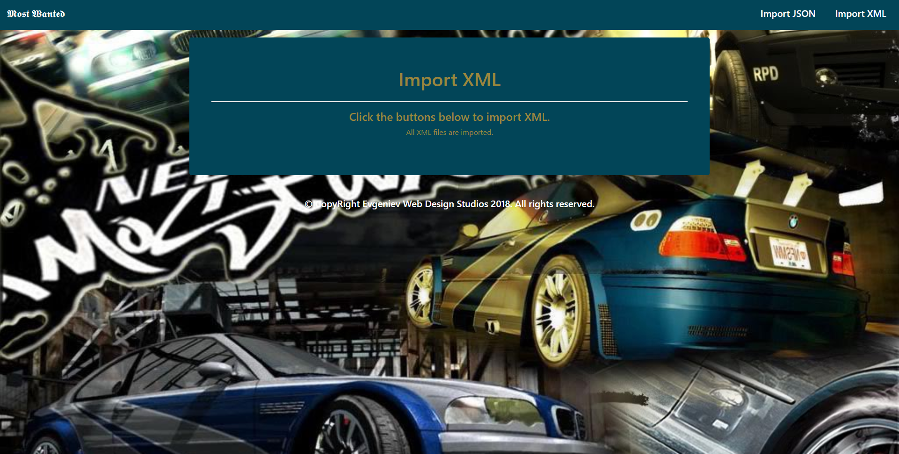

* Home page after importing the given data:

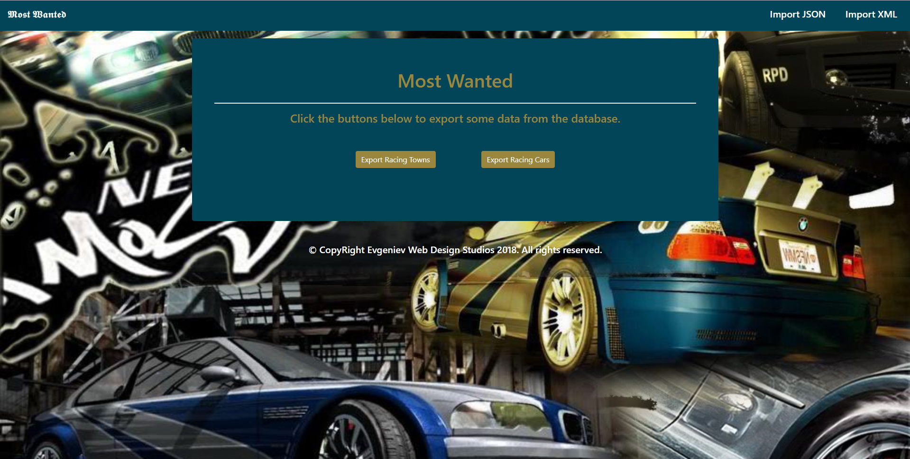

* Export Racing Towns page:

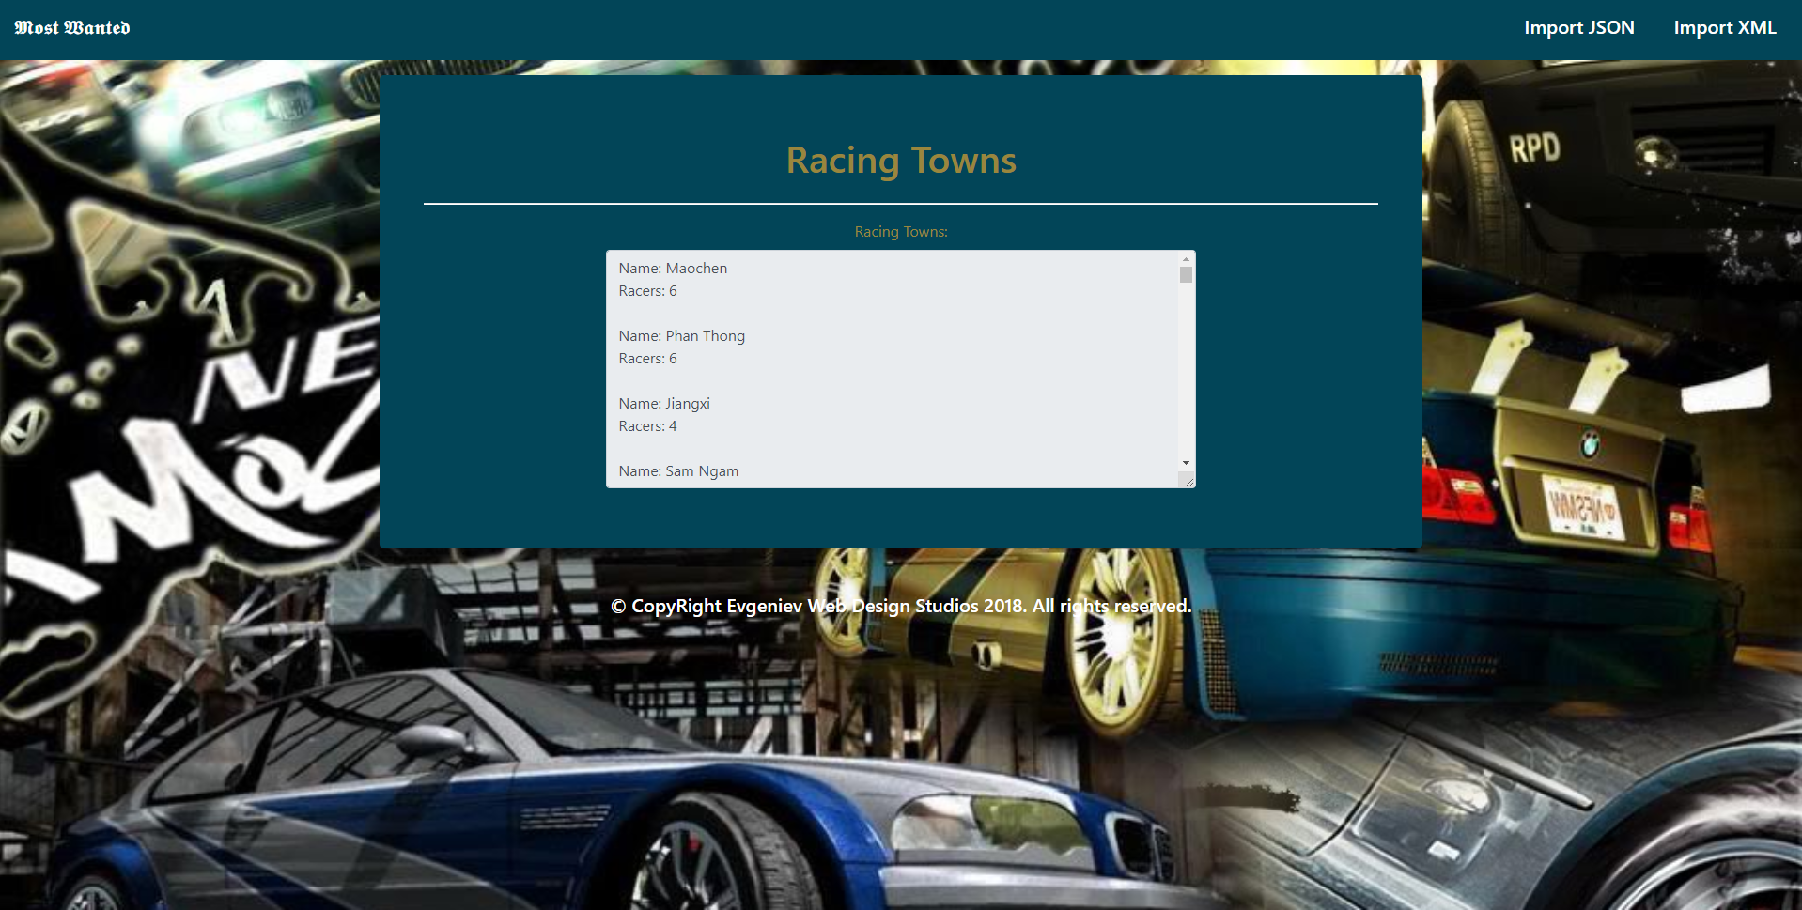

* Export Racing Cars page:

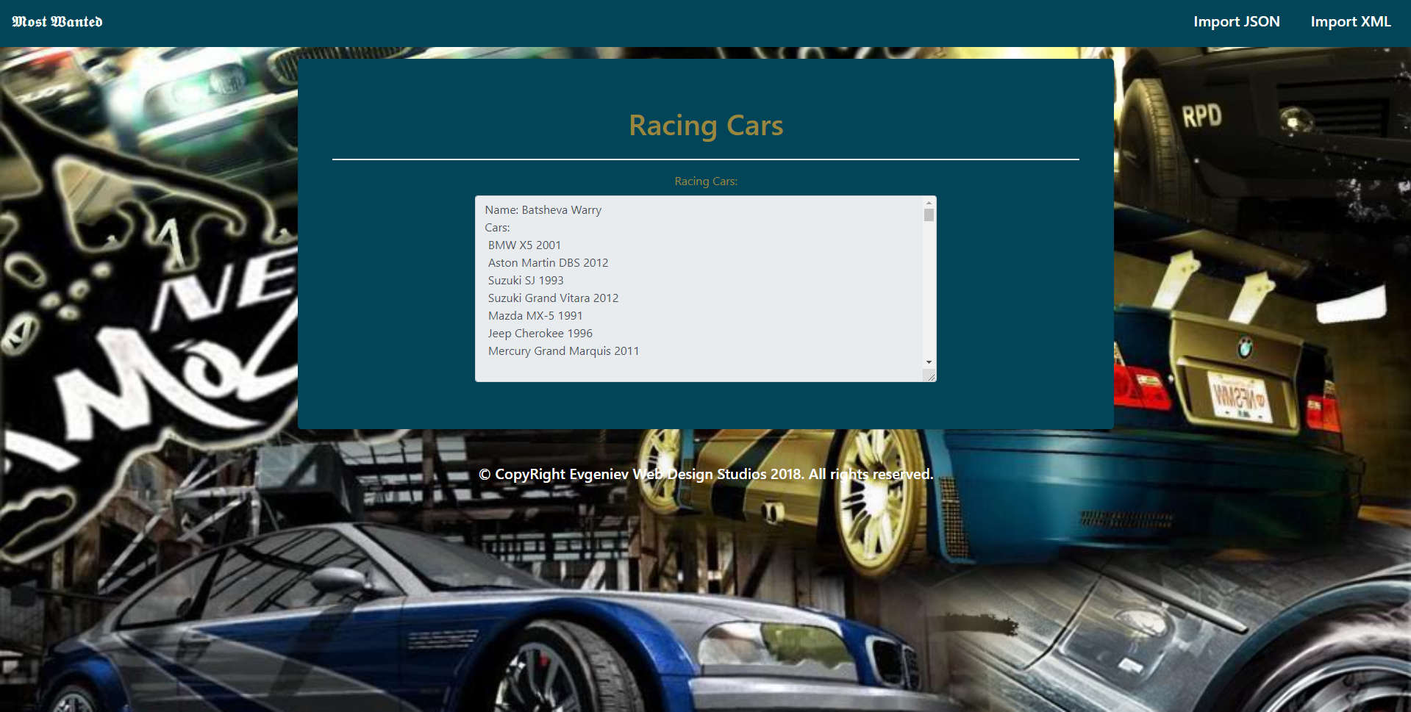

## Project Skeleton Overview

You will be given a **Skeleton**, containing a **certain architecture** with **several classes**, some of which – completely empty. The **Skeleton** will include the **files** with which you will **seed** the **database**.

## Model Definition

There are 6 main models that the **Most Wanted** database application should contain in its functionality.

Design them in the **most appropriate** way, considering the following **data constraints**:

### Town

* id – **integer** number, **primary identification field**.
* name – a **string** (**required, unique**).

### District

* id – **integer** number, **primary identification field**.
* name – a **string** (**required, unique**).
* town – a Town entity.

### Racer

* id – **integer** number, **primary identification field**.
* name – a **string** (**required, unique**).
* age – an **integer** number.
* bounty – a **decimal** data type.
* homeTown – a Town entity.
* cars – a collection of Car entity.

### Car

* id – **integer** number, **primary identification field**.
* brand – a **string** (**required**).
* model – a **string** (**required**).
* price – a **decimal** data type.
* yearOfProduction – an **integer** number (**required**).
* maxSpeed – a **floating-point** data type.
* zeroToSixty – a **floating-point** data type.
* racer – a Racer entity.

### Race

* id – **integer** number, **primary identification field**.
* laps – **integer** number (**required**, **default** – **0**)
* district – a District entity (**required**).
* entries – a collection of RaceEntry entity.

### RaceEntry

* id – **integer** number, **primary identification field**.
* hasFinished – a **boolean** value.
* finishTime – a **floating-point** data type.
* car – a Car entity.
* racer – a Racer entity.

You are also given an E/R Diagram for better understanding of the database:

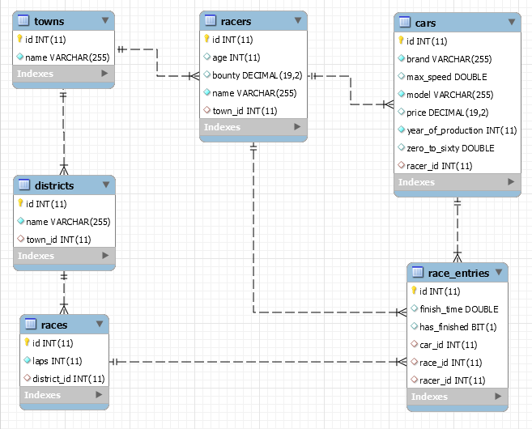

## Data Import

Use the provided **JSON** and **XML** files to populate the database with data. Import all the information from those files into the database.

**You are not allowed to modify the provided JSON and XML files.**

**ANY UNALLOWED DUPLICATE** data should be **ignored** and a message “Error: Duplicate Data!” should be printed.

**ANY INCORRECT** data should be **ignored** and a message “Error: Incorrect Data!” should be printed.

**ANY SUCCESSFUL** data import should **result** in a message “Successfully imported {entityClass} – {entityField}.”.

The entityField depends on the entityClass:

* For Towns, Districts, Racers – {name}.
* For Cars – a string **composed** in the following format – “{brand} {model} @ {yearOfProduction}”
* For Race, RaceEntry – {id};

### JSON Import (10 pts)

#### Towns (towns.json)

|  |
| --- |
| **towns.json** |
| [  { "name" : "München" },  { "name" : "Maastricht" },  . . .  ] |

|  |
| --- |
| Successfully imported Town - München.  Successfully imported Town - Maastricht.  . . . |

#### Districts (districts.json)

|  |
| --- |
| **districts.json** |
| [  { "name" : "Larry", "townName" : "Maastricht" },  { "name" : "Transport", "townName" : "München" },  . . .  ] |

|  |
| --- |
| Successfully imported District - Larry.  Successfully imported District - Transport.  . . . |

#### Racers (racers.json)

|  |
| --- |
| **racers.json** |
| [  {  "name" : "Clarence Callahan",  "age" : 34,  "bounty" : 164177.22,  "townName" : "Troyes"  },  . . .  ] |

|  |
| --- |
| Successfully imported Racer - Clarence Callahan.  . . . |

#### Cars (cars.json)

|  |
| --- |
| **cars.json** |
| [  {  "brand" : "Volvo",  "model" : "C70",  "price" : 487452.02,  "yearOfProduction" : 2010,  "maxSpeed" : 161.6,  "zeroToSixty" : 2.24,  "racerName" : "Brigit Speller"  },  . . .  ] |

|  |
| --- |
| Successfully imported Car - Volvo C70 @ 2010.  . . . |

### XML Import

The ARPU are not very smart, so their data seeds are quite messed up.   
You will need to **import** the RaceEntries first, and then import all Races with their entries.

#### Race Entries (race-entries.xml)

|  |
| --- |
| **race-entries.xml** |
| <?xml version="1.0" encoding="utf-8"?>  <race-entries>  <race-entry has-finished="true" finish-time="741.12" car-id="269">  <racer> Max Philpott</racer>  </race-entry>  <race-entry has-finished="false" finish-time="822.96" car-id="242">  <racer> Wylie Gareisr</racer>  </race-entry>  <race-entry has-finished="true" finish-time="156.57" car-id="220">  <racer> Murial Jedrzejewicz</racer>  </race-entry>  ...  </race-entries> |

|  |
| --- |
| Successfully imported RaceEntry - 1.  Successfully imported RaceEntry - 2.  Successfully imported RaceEntry - 3.  . . . |

#### Races (races.xml)

|  |
| --- |
| **races.xml** |
| <?xml version="1.0" encoding="utf-8"?>  <races>  <race>  <laps>4</laps>  <district-name>Jackson</district-name>  <entries>  <entry id="10">  <entry id="9">  </entries>  </race>  ...  </races> |

|  |
| --- |
| Successfully imported Race - 1.  . . . |

## Data Export

Get ready to export the data you’ve imported in the previous task. Here you will have some pretty complex database querying.

#### Racing Towns

**Export all towns** which have **any** **racers** in them:

* **Export** only the **town name** (as name) and **count of racers** (as racers).
* **Order** them **descending**, by **count** of **racers** they have, and then by **town** **name alphabetically**.

## 

#### Racing Cars

**Export** **all racers** which **have any cars**:

* **Export** the racer’s **name**, **age** (but **ONLY** if it is **NOT NULL**), **list** of **cars**.
  + In case the **racer’s age** property is **NULL**, do **NOT** include it.
* The **cars** should be **strings** in the following format: “{brand} {model} {yearOfProduction}”.
* **Order** them **descending**, by **count** of **cars** they have, and then by **racer name alphabetically**.

